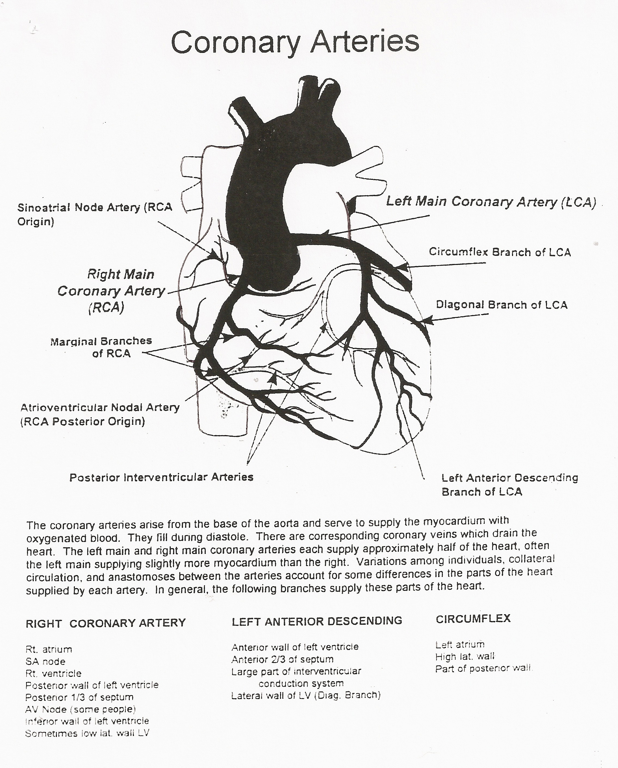

The coronary arteries arise from the base of the aorta and supply the myocardium with oxygenated blood. They fill during diastole. There are corresponding coronary veins which drain the myocardium. The left main and right main coronary arteries each supply approximately half of the heart, often the left main supplies slightly more myocardium than the right coronary artery. Variations among individuals, collateral circulation, and anastomoses between the arteries account for some differences in the parts of the heart that are supplied by each artery. In general, the following branches supply these parts of the heart:

RIGHT CORONARY LEFT ANTERIOR CIRCUMFLEX
ARTERY DESCENDING
Rt. atrium Anterior wall of LV Left atrium
SA node Ant 2/3 of septum High lateral wall
Post wall of LV of left vent.
Rt. ventricle Large part of inter- Part of posterior
Post 1/3 of septum vent. conduction wall.
AV Node (majority system.
of people.)
Inferior wall of LV
Sometimes, low lat
wall of LV

